### **Use Case Scenario: Automated Attendance System**

#### **Use Case: Mark Student Attendance**

**Group Name:** Boys at the Back

**Members:**

Rudilito Dongiapon Jr.  
Jhon Ryan Pagantian  
Cristian Villanueva  
Frances Al Capiña

**Actors:**

* **Primary Actor:** Lecturer
* **Secondary Actors:** Student, Administrator

**Preconditions:**

* The lecturer must be logged into the system.
* The class session must be scheduled in the system.
* Students must be registered in the system.

**Main Flow:**

1. The lecturer logs into the system.
2. The lecturer selects the course and class session.
3. The system displays the list of enrolled students.
4. The lecturer chooses the attendance marking method (e.g., QR code, biometric, manual).
5. Students mark their attendance using the selected method.
6. The system validates the student’s presence.
7. Attendance records are updated in real-time.
8. The lecturer submits the attendance record.
9. The system stores the attendance data in the database.
10. The system generates an attendance report.

**Alternate Flows:**

* **Invalid Student Attempt:** If a student who is not registered for the course tries to mark attendance, the system denies access and notifies the lecturer.
* **Missed Attendance:** If a student fails to mark attendance within the given timeframe, the system marks them absent.
* **Offline Mode:** If the internet is unavailable, the system stores attendance data locally and syncs once connected.

**Postconditions:**

* Attendance records are successfully stored in the database.
* Reports are accessible to lecturers and administrators.
* Students can view their attendance status.

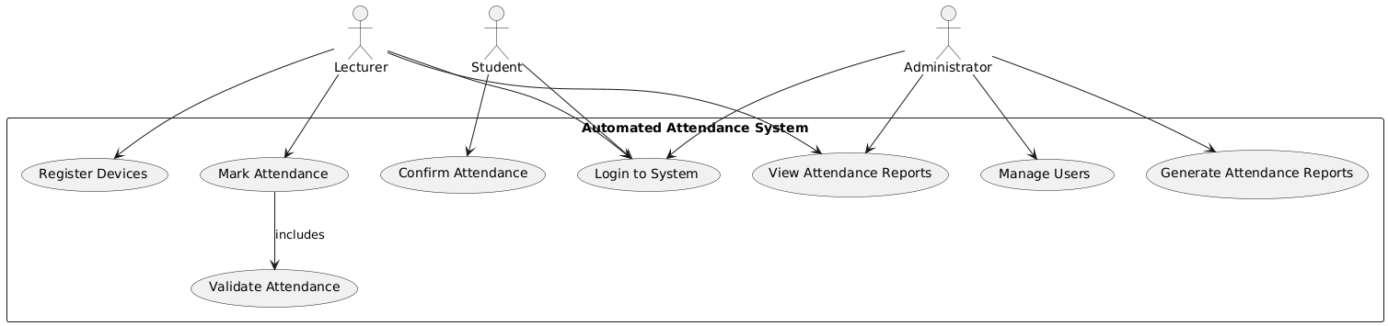

### **Use Case Scenario: Generate Attendance Report**

#### **Use Case Name:** Generate Attendance Report

#### **Actors:**

* **Primary Actor:** Administrator
* **Secondary Actor:** Lecturer

#### **Preconditions:**

* The administrator or lecturer must be logged into the system.
* Attendance records must be available in the system.

#### **Main Flow:**

1. The administrator logs into the system.
2. The administrator navigates to the **Reports** section.
3. The system provides filters (e.g., by course, date range, student, lecturer).
4. The administrator selects the desired filters.
5. The administrator requests to generate the report.
6. The system processes the request and retrieves relevant attendance data.
7. The system formats the report (e.g., table, PDF, CSV).
8. The system displays the generated report.
9. The administrator downloads or prints the report.

#### **Alternate Flows:**

* **Invalid Date Range:** If the selected date range has no attendance records, the system notifies the user and prompts them to adjust the filters.
* **Export Options:** The administrator may choose to export the report in different formats (e.g., CSV, PDF).
* **Access Restriction:** A lecturer can only generate reports for the classes they are assigned to, while administrators have full access.

#### **Postconditions:**

* The requested attendance report is generated and available for download.
* The administrator or lecturer can use the report for record-keeping or further analysis.

